
KJEI’s

K. J. College of Engineering & Management Research
(Accredited by NAAC) Sr. No. 25 & 27, Kondhwa Saswad Road, Near Bopdev Ghat, Pune 411048.

Department of Computer Engineering

“Smart CNG Reservation System”

Group Members:
- Prathamesh Gaikwad (A-25)
- Shreyash Jangam (A-43)
- Kadambari Kale (A-45)
- Sujit Kale (A-66)

Project Guide :
Prof. Mayuri Vengurlekar.

- Title of the Project: “Smart CNG Reservation System”
- Abstract:
The Smart CNG Reservation System is designed to digitize and streamline the process of booking slots for Compressed Natural Gas (CNG) refueling. The existing manual or first-come-first-serve methods lead to long queues and fuel station congestion. This system provides an efficient solution through online slot booking, reducing waiting time and enhancing user convenience.

- Introduction / Background:
The proposed system will be a web-based application where users can register, log in, view available time slots, and book their CNG refueling. Admins will manage slots, view user data, and monitor booking activity. Users will receive confirmations and can cancel or modify bookings. The system will maintain historical data for both users and admins. To address these challenges, a Smart CNG Reservation System is proposed. This system leverages modern technologies such as web and mobile applications, GPS, real-time data analytic’s, and digital payment gateways to streamline the entire CNG refueling experience. The platform allows users to pre-book time slots, locate nearby CNG stations, check real-time availability, and even make advance payments to ensure a hassle-free and organized refueling process.

- Objectives of the Project:
  - To provide a user-friendly platform for booking CNG refueling slots.
  - To minimize congestion and waiting times at CNG stations.
  - To allow station administrators to manage reservations and availability efficiently.
  - To enable better time management for users and fuel stations.
  - To reduce manual workload and errors in CNG distribution.

- Methodology

1. Frontend Development – Designing user-friendly interfaces using HTML, CSS, JavaScript.
2. Backend Development – Developing business logic using JSP and Servlets.
3. Database Integration – Connecting MySQL database with Java backend.
4. Admin & User Module – Providing different interfaces for booking and management.
5. Testing & Deployment – Using Apache Tomcat to test and deploy the WAR file.

- Block Diagram:
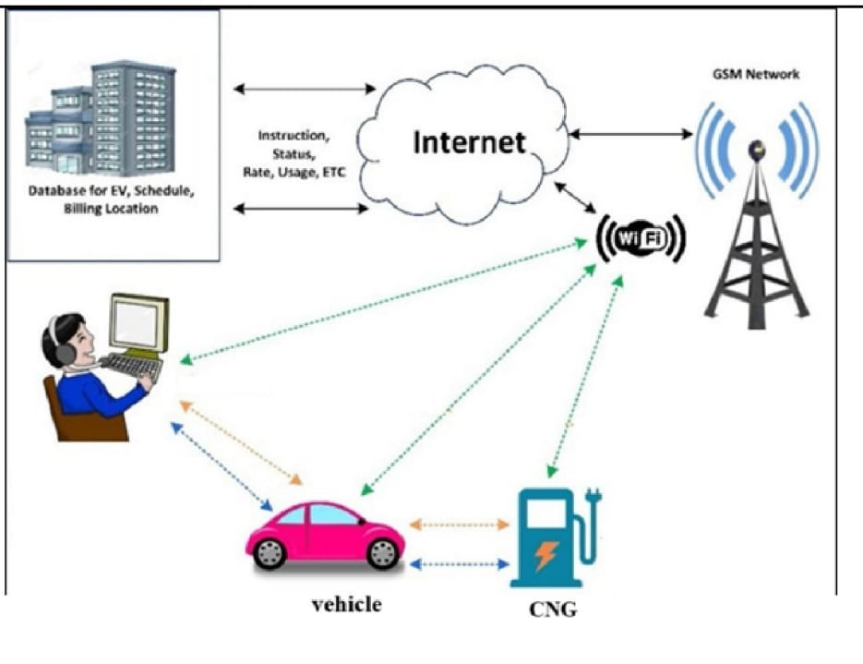

- System Requirements:
Hardware Requirements:
• Computer system (Windows/Linux) for development and deployment.
• Minimum 4 GB RAM and 100 GB Hard Disk.
• Internet-enabled devices (desktop/laptop/mobile) for users.
• Local server or cloud server for deployment.

Software Requirements:
• Programming Language: Java
• IDE: Eclipse / IntelliJ IDEA / NetBeans
• Web Server: Apache Tomcat
• Frontend: HTML, CSS, JavaScript
• Backend: JSP, Servlets
• Database: MySQL
• Database Tool: MySQL Workbench / phpMyAdmin
• Build Tool: Apache Maven (if used)

- Proposed System / Methodology:

The proposed system will be a web-based application where users can register, log in, view available time slots, and book their CNG refueling. Admins will manage slots, view user data, and monitor booking activity. Users will receive confirmations and can cancel or modify bookings. The system will maintain historical data for both users and admin

- Expected Outcome:
• A fully functional web application for CNG slot reservations.
• Reduced waiting time and congestion at CNG stations.
• Proper tracking of fuel usage and user statistics.

- Project Plan and Timeline

Phase | Duration
Research | 4 weeks
Datasets & Preprocessing | 4 weeks
Model development | 8 weeks
Evaluation & testing | 3 weeks
Report & Deployment | 3 weeks

- Literature Survey:
Most CNG stations currently do not use digital reservation systems, leading to unmanaged queues and user dissatisfaction.
Web and mobile-based reservation systems are common in domains like restaurant and clinic appointments, but are rarely applied to fuel management.
The system design is inspired by existing reservation platforms to bridge the gap in CNG station digitization.
A study titled “Online Booking System for CNG Pump” (IJSRD, 2023) proposed a web-based system allowing users to pre-book time slots at nearby CNG stations. It integrates Google Maps API to locate the nearest stations and allows real-time slot monitoring. The paper highlights significant reductions in queue time and better management of peak-hour congestion. However, it lacks integration with payment gateways and advanced predictive analytics.
The paper "Streamline Your Drive: Pre-Booking & Pre-Paid Parking slots, Locating CNG Stations & EV Charging Stations", Conference Paper, 2024, proposes an integrated platform for slot-based parking reservations and locating fuel/EV stations, offering strong parallels to the CNG reservation model.
The paper 'PumpIt – CNG Gas Booking and Availability System', IJSREM, Vol. 4, Issue 3, 2025, introduces a similar booking model for CNG slots and provides a real-time availability system.
The paper 'Design and Development of Online Gas Booking System', IJERT, Vol. 12, Issue 3, 2023, outlines the core architecture of an online gas booking portal and highlights benefits of user-admin interfacing.

- Applications:
    - CNG Fuel Stations
    - Gas Agencies
    - Government and private transport hubs
    - Future integration with mobile apps and smart vehicles

- Conclusion:
The Smart CNG Reservation System addresses a real and growing need in fuel station management. By enabling online bookings and time-slot management, it increases efficiency, saves users' time, and improves the overall experience of CNG refueling. This project represents a practical and scalable solution for the fuel distribution sector.

- References Books & Research Papers:
S.no | Title | Source | Year | Key Contribution
1 | Streamline Your Drive: Pre-Booking & Pre-Paid Parking Slots, Locating CNG Stations & EV Charging Stations | IEEE Xplore | 2024 | Proposes a unified system for pre-booking and prepaid parking, integrated with GPS-based location of CNG and EV stations
2 | PumpIt – CNG Gas Booking and Availability System | IJSREM, Vol 4,Issue 3 | 2025 | Web-based platform for real-time availability checks and appointment booking; includes admin interface for station management
3 | Design and Development of Online Gas Booking System | IJERT, Vol. 12, Issue 3 | 2023 | Digital platform enabling user registration, order placement, and notifications for booking CNG/LPG refills
4 | Bio-Fuel Booking System Using Machine Learning | IEEE / Studocu reference (ML) | 2022 | Incorporates machine learning techniques to predict bio-fuel demand using historical data, weather, and consumer habits; relevant for demand optimization

Web References & Technical Articles:
1. https://www.oracle.com/java/
2. https://tomcat.apache.org/
3. https://dev.mysql.com/
4. https://www.javatpoint.com/jsp-tutorial

